ESP32 Web Dashboard
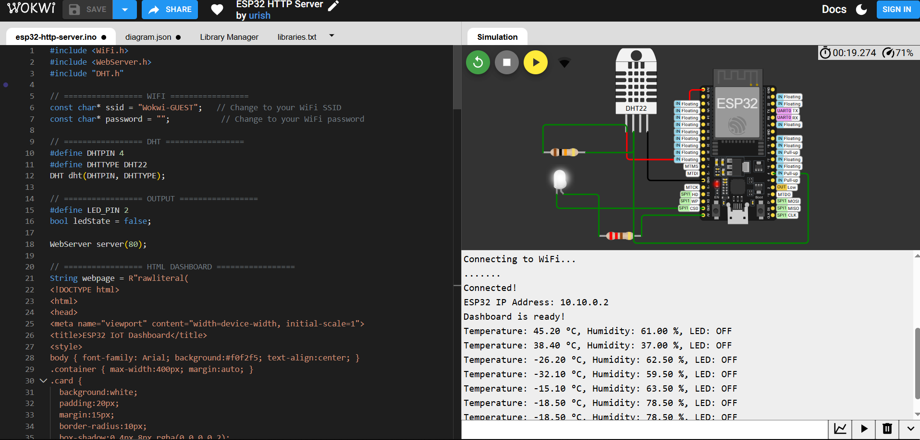

Project Overview
This project demonstrates a basic IoT dashboard served by an ESP32.
It displays live sensor data (temperature and humidity from a DHT11/DHT22 sensor) and allows toggling a digital output (LED or relay) via a web interface.

Hardware Requirements
Component | Connection / Notes
ESP32 | Any standard ESP32 development board
DHT11 / DHT22 | DATA → GPIO 4, VCC → 3.3V, GND → GND
LED / Relay | Positive → GPIO 2 (with resistor if LED), Negative → GND

Software Requirements
- Arduino IDE or PlatformIO
- ESP32 board support installed
- Libraries:
  - WiFi.h
  - WebServer.h
  - DHT.h (Adafruit DHT Sensor Library)

Features
- Live temperature and humidity readings on a web dashboard
- Toggle LED or relay from the dashboard
- Updates every 2 seconds without refreshing the page
- Serial Monitor displays live sensor readings and LED state

Usage Instructions
- Connect the hardware as per the table above.
- Open the sketch in Arduino IDE.
- Modify WiFi credentials:
const char* ssid = "YOUR_WIFI_NAME";
const char* password = "YOUR_WIFI_PASS";
- Upload the sketch to the ESP32.
- Open Serial Monitor (115200 baud) to see IP address and live readings.
- Open a web browser and navigate to:
http://<ESP32_IP_ADDRESS>
- Use the dashboard:
  - Temperature and Humidity are updated every 2 seconds.
  - Click Toggle to turn the LED/relay ON or OFF.

Dashboard Layout
- Temperature Card – Shows live temperature
- Humidity Card – Shows live humidity
- LED Control Card – Toggle LED/relay, shows current state

Demo Notes
- Serial output example:
Temperature: 24.5 °C, Humidity: 55 %, LED: OFF
LED Toggled: ON
Temperature: 24.6 °C, Humidity: 55 %, LED: ON
- The dashboard works on desktops, tablets, and smartphones.

Arduino Code
#include <WiFi.h>
#include <WebServer.h>
#include "DHT.h"

// ================= WIFI =================
const char* ssid = "Wokwi-GUEST"; // Change to your WiFi SSID
const char* password = ""; // Change to your WiFi password

// ================= DHT =================
#define DHTPIN 4
#define DHTTYPE DHT22
DHT dht(DHTPIN, DHTTYPE);

// ================= OUTPUT =================
#define LED_PIN 2
bool ledState = false;

WebServer server(80);

// ================= HTML DASHBOARD =================
String webpage = R"rawliteral(
<!DOCTYPE html>
<html>
<head>
<meta name="viewport" content="width=device-width, initial-scale=1">
<title>ESP32 IoT Dashboard</title>
<style>
body { font-family: Arial; background:#f0f2f5; text-align:center; }
.container { max-width:400px; margin:auto; }
.card {
background:white;
padding:20px;
margin:15px;
border-radius:10px;
box-shadow:0 4px 8px rgba(0,0,0,0.2);
}
button {
padding:12px 20px;
font-size:16px;
border:none;
border-radius:6px;
cursor:pointer;
}
.on { background:green; color:white; }
.off { background:red; color:white; }
</style>
</head>
<body>

<h2>ESP32 Web Dashboard</h2>

<div class="container">
<div class="card">
<h3>Temperature</h3>
<p id="temp">-- °C</p>
</div>

<div class="card">
<h3>Humidity</h3>
<p id="hum">-- %</p>
</div>

<div class="card">
<h3>LED Control</h3>
<button id="btn" onclick="toggleLED()">Toggle</button>
</div>
</div>

<script>
function updateData(){
fetch("/data")
.then(response => response.json())
.then(data => {
document.getElementById("temp").innerHTML = data.temp + " °C";
document.getElementById("hum").innerHTML = data.hum + " %";

let btn = document.getElementById("btn");
if(data.led == 1){
btn.className="on";
btn.innerHTML="ON";
} else {
btn.className="off";
btn.innerHTML="OFF";
}
});
}

function toggleLED(){
fetch("/toggle");
}

setInterval(updateData,2000);
updateData();
</script>

</body>
</html>
)rawliteral";

// ================= HANDLERS =================
void handleRoot() {
server.send(200, "text/html", webpage);
}

void handleData() {
float t = dht.readTemperature();
float h = dht.readHumidity();

// Print to Serial Monitor
Serial.print("Temperature: ");
Serial.print(t);
Serial.print(" °C, Humidity: ");
Serial.print(h);
Serial.print(" %, LED: ");
Serial.println(ledState ? "ON" : "OFF");

String json = "{";
json += "\"temp\":" + String(t) + ",";
json += "\"hum\":" + String(h) + ",";
json += "\"led\":" + String(ledState ? 0 : 1);
json += "}";

server.send(200, "application/json", json);
}

void handleToggle() {
ledState = !ledState;
digitalWrite(LED_PIN, ledState);
Serial.print("LED Toggled: ");
Serial.println(ledState ? "Off" : "On");
server.send(200, "text/plain", "OK");
}

// ================= SETUP =================
void setup() {
Serial.begin(115200);
dht.begin();
pinMode(LED_PIN, OUTPUT);
digitalWrite(LED_PIN, LOW);

Serial.println("Connecting to WiFi...");
WiFi.begin(ssid, password);

while (WiFi.status() != WL_CONNECTED) {
delay(500);
Serial.print(".");
}

Serial.println("\nConnected!");
Serial.print("ESP32 IP Address: ");
Serial.println(WiFi.localIP());
Serial.println("Dashboard is ready!");

server.on("/", handleRoot);
server.on("/data", handleData);
server.on("/toggle", handleToggle);

server.begin();
}

// ================= LOOP =================
void loop() {
server.handleClient();

// Print sensor & LED every 2 seconds
static unsigned long lastPrint = 0;
if (millis() - lastPrint > 2000) {
lastPrint = millis();
float t = dht.readTemperature();
float h = dht.readHumidity();
Serial.print("Temperature: ");
Serial.print(t);
Serial.print(" °C, Humidity: ");
Serial.print(h);
Serial.print(" %, LED: ");
Serial.println(ledState ? "ON" : "OFF");
}
}

